Publicity Contact: Author Contact:
Shari Stauch Chris Leibig
shari@writerswin.com chris@chrisleibiglaw.com
843.834.1872 703-683-4310

FOR IMMEDIATE RELEASE

Christopher Leibig’s Third Novel, ALMOST MORTAL Releases May 1, 2016
Highly Anticipated Legal Thriller Release from Koehler Books

February 15, 2016: Almost Mortal, a new legal thriller from author Christopher Leibig (soft cover, 6x9”, 242 pp., $15.95) releases May 1, 2016. Publisher Koehler Books calls Almost Mortal “a fast-paced legal thriller with a rough and tumble, brilliant protagonist.”

The novel, Leibig’s third, features criminal defense attorney Sam Young, a Virginia public defender who aims to protect a priest by stopping a confessed serial killer from committing another murder. Realistic, poignant, and even funny scenes about the life of a public defender are juxtaposed against supernatural elements as Sam’s strange psychic abilities increase the tension.

Kirkus Reviews says, “A poised protagonist leads this serpentine but engaging legal tale” and AuthorsReading.com wrote, “…You will sit down with Almost Mortal and not want to put it down.”

Published by Koehler Books and distributed by Ingram, Almost Mortal will release in both soft cover (978-1-63393-179-4, $15.95) and ebook (978-1-63393-180-0, $4.99) in May, 2016. Advanced reader copies in pdf format are available now. Visit www.koehlerbooks.com.

About the Author
Christopher Leibig is a novelist and criminal defense lawyer who lives and works in Alexandria, Virginia. His first two novels, Saving Saddam (2008), and Montanamo (2010) were published by Artnik Books in London. Saving Saddam was re-released in the United States in 2014 by Traveller’s Playground Press under the title Blackrabbit. Chris also has several published short stories and has published numerous articles on criminal defense and related topics – including in the Huffiington Post and The Examiner – and has appeared as a legal expert regularly since 2009 in print and television media – including Fox News, CNN, The Washington Post, The New York Times, and Sports Illustrated. In recent years Leibig has regularly handled high profile criminal cases in the DC area and travelled abroad to speak to law schools. Visit www.chrisleibig.com.

Photos/Interviews Available on Request

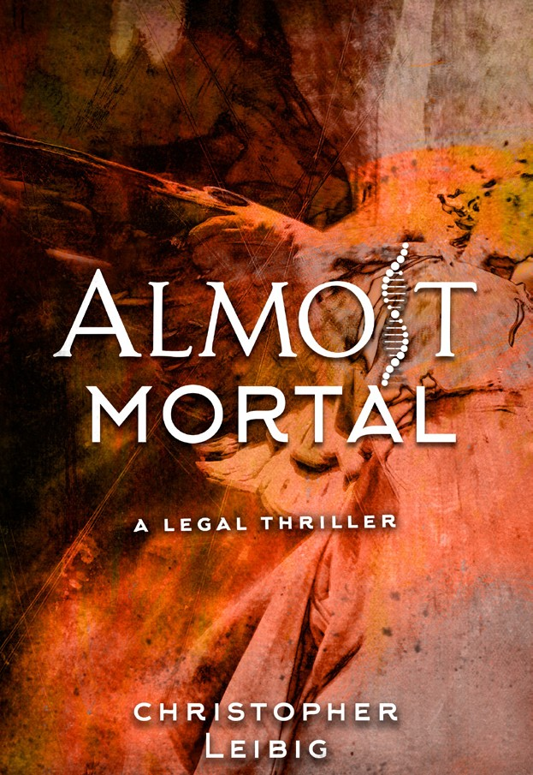
EARLY PRAISE FOR ALMOST MORTAL

“A beautiful and heartbreaking story of friendship and survival, abuse and retribution, love and justice, told without sentimentality but with a reporter’s sharp and spare prose.” – Arianna Huffington, editor-in-chief, The Huffington Post
“An excellent writer, highly recommended.” – Tom Franklin, award-winning author of
Crooked Letter, Crooked Letter and Hell at the Breech
“A contemporary Southern version of Sherwood Anderson’s Winesburg, Ohio. Exquisitely wrought, spare and gorgeous prose, wonderful dialogue–this book is a winner and highly recommended.” – Denise Hamilton, best-selling author of the Eve Diamond crime novels
“For those of us who grew up experiencing New Orleans… Thanksgiving hits close to home– maybe too close. It’s like stories we’re hearing from cousins about long-hidden family secrets. It flows freely, like hot beignets and coffee and chicory at Cafe du Monde on a crisp morning during football season.” – P.M. LaRose, author of First Case of Beers
“From bayou mystique to Big Easy intrigue, here is an authentic Louisiana tale, well told. With characters that exude all the quirks and charm of exotic New Orleans and its environs, Thanksgiving navigates a gauntlet of trauma, survival and redemption and delivers a story that will keep readers in its grip from start to finish.” – Ron Thibodeaux, author of Hell or High Water: How Cajun Fortitude Withstood Hurricanes Rita and Ike.

